Peggy Parish

From www.harpercollinschildrens.com

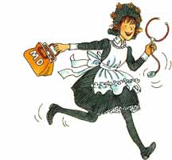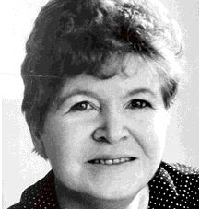The late Peggy Parish, well known for her stories about Amelia Bedelia, wrote many popular books for children.  
  
“I hate reading but your books are changing my opinion.” This letter, from a young Peggy Parish fan, comes as no surprise to the teachers and librarians who have put her books in the hands of children over the years. Ms. Parish wrote nearly three dozen children’s books—many of which include her most famous character, the literal-minded housekeeper named Amelia Bedelia.   
  
Peggy Parish knew what children liked to read. After graduating from the University of South Carolina with a degree in English, she taught school in Oklahoma, Kentucky, and for more than fifteen years at the well-known, progressive Dalton School in New York City. It was at Dalton that she began to find ways to release her creative ideas and energy. Though she never took a writing course, “writing stories for children came naturally.” Her first book, published in 1961, was followed with *Let’s Be Indians* and, in 1963, her unforgettable *Amelia Bedelia*.   
  
Always involved with education in some way, Peggy Parish did television pieces on preschool education and children’s books, wrote children’s-book review columns, and led numerous in-service training workshops for teachers. In discussing her ideas about education she said, “Children’s rights are taken away from them when they enter school. What I try to show teachers is that all the skills needed to read can be taught outside of textbooks. Today’s children are not going to read what they are not interested in. And if a positive attitude toward reading is not developed during the first three years of school, it is virtually impossible to develop it later.”   
  
After living in New York for many years, Peggy Parish returned to her native South Carolina. She died in November 1988. In 1995, Peggy Parish’s nephew, Herman Parish, brought Amelia Bedelia back into the world with a new adventure, *Good Driving, Amelia Bedelia*, and he has continued to charm readers with her mishaps ever since.

4

1 According to the passage, which book was published in 1961?

A Amelia Bedelia

B Dalton School

C Good Driving

D Let’s Be Indians

2 Peggy Parish believed that-

A Reading can only be taught with a text book

B Amelia Bedelia was silly

C Children would read books they found interesting

D Reading was too hard the first three years

3 Herman Parish is Peggy Parish’s-

A nephew

B son

C husband

D friend

4 What does virtually mean as it is used in paragraph 4?

A never

B difficult

C almost

D imaginary

5 Where did Peggy Parish go to college?

A University of Oklahoma

B University of South Carolina

C Dalton School

D University of Arkansas

Peggy Parish said, “Children’s rights are taken away from them when they enter school.” What did she mean by that? How can teachers help children keep their rights?

____________________________________________________________________________________________________________________________________________________________________________________________________________________________________________________________________

Why did Peggy Parish write the Amelia Bedelia books? What do you think she wanted her readers to do after reading them?

____________________________________________________________________________________________________________________________________________________________________________________________________________________________________________________________________

“I hate reading but your books are changing my opinion.”

Why did the author include this quote from a fan’s letter to Peggy Parish?

____________________________________________________________________________________________________________________________________________________________________________________________________________________________________________________________________